# Installing Anaconda on

# Windows Tutorial

*let's get started!*

## Download and Install Anaconda

1. Go to the **[Anaconda Website](https://www.anaconda.com/download/" \l "windows)**
2. **https://www.anaconda.com/**
3. Locate your download and double click it.



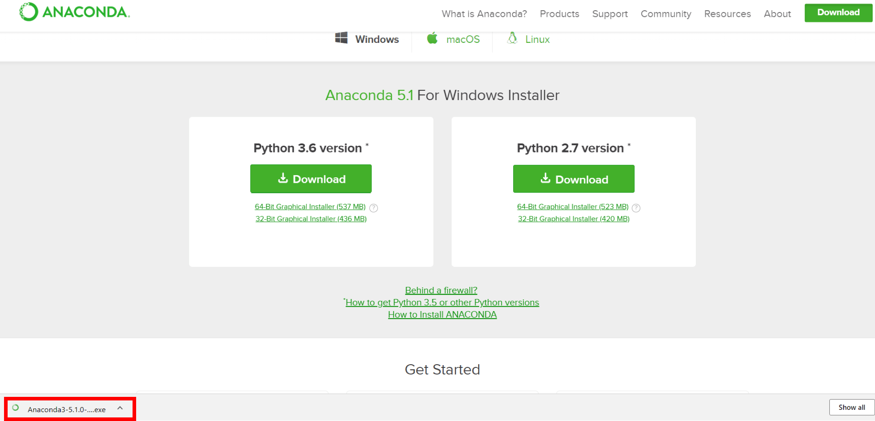

When the screen below appears, click on Next.

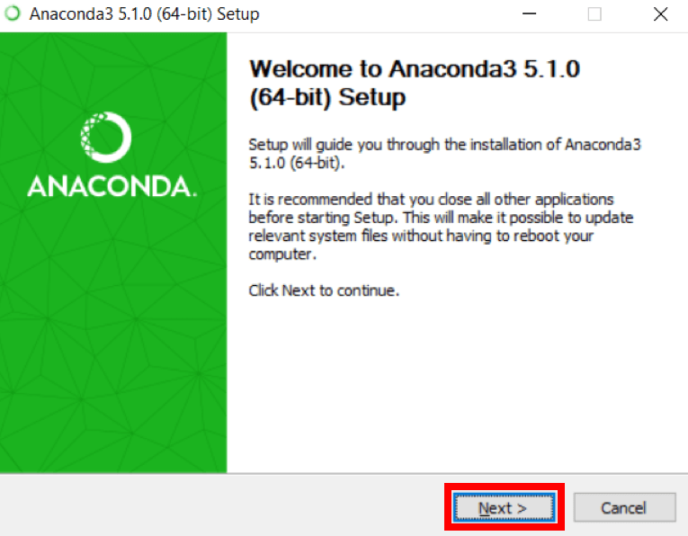

3. Read the license agreement and click on I Agree.

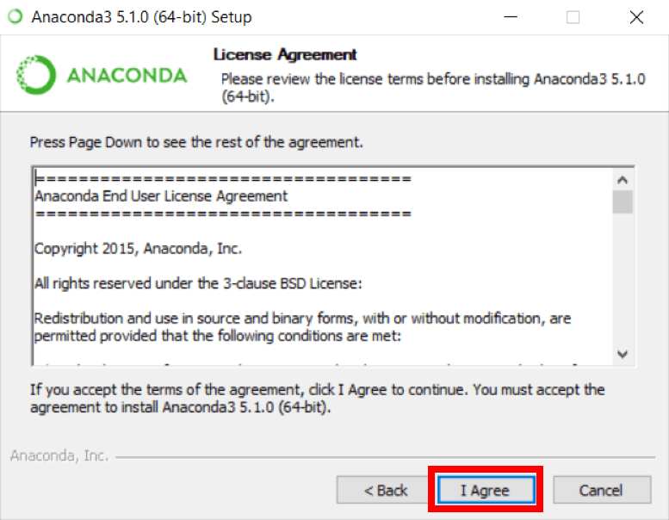

 4. Click on Next.

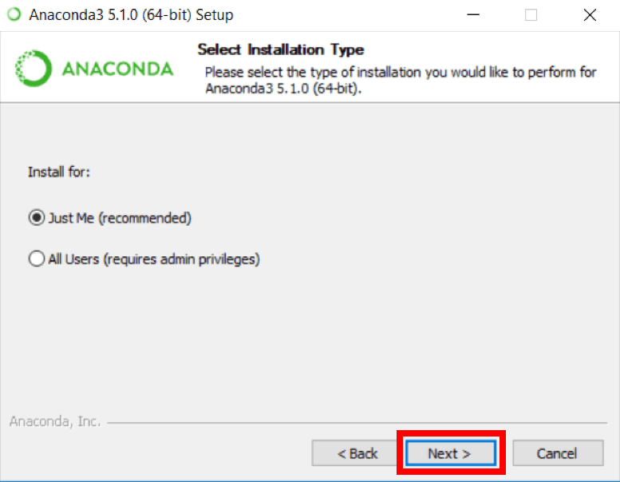

5. Note your installation location and then click Next.

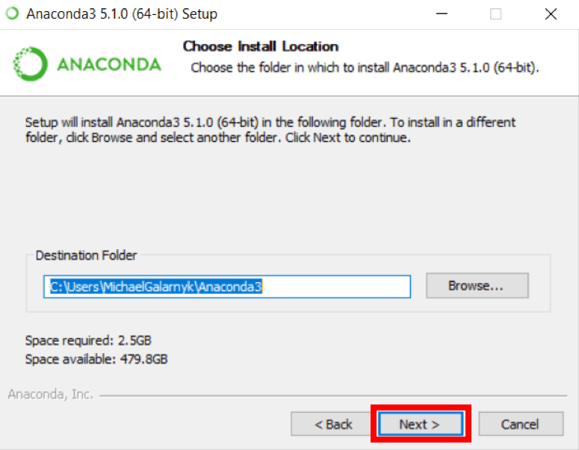

 6. This is an important part of the installation process. The recommended approach is to not check the box to add Anaconda to your path. This means you will have to use Anaconda Navigator or the Anaconda Command Prompt (located in the Start Menu under "Anaconda") when you wish to use Anaconda (you can always add Anaconda to your PATH later if you don't check the box). If you want to be able to use Anaconda in your command prompt (or git bash, **[cmder](http://cmder.net/)**, powershell etc), please use the alternative approach and check the box.

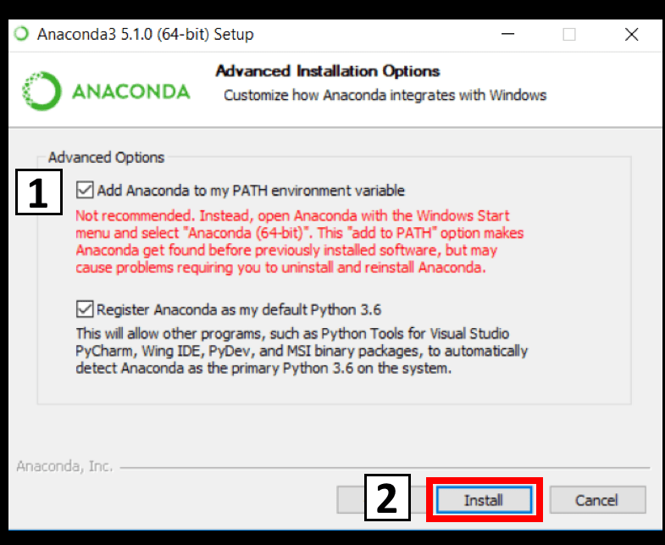

7. Click on Next.

